True colors test <https://my-personality-test.com/results/6874431008031939740/true-colours>

YOUR PERSONALITY TYPE IS

Gold

**Your true color is gold!**

You are very detail-oriented and love to plan ahead. You are very predictable and responsible, which gives you a sense of security in life. You rarely do anything that is unpredictable or unplanned.

You also value history and tradition. You hold your family’s shared beliefs very closely, and have a high moral standard. You enjoy finding ways to live out these values in various ways throughout your life, whether that be through helping others by volunteering or through your career. You enjoy having others rely on you to help.

You enjoy being the best at what you do, and believe there is a right way to do everything. Others would describe you as a “*rule-followe*r” who “*does things by the book*”.  Because of this, you can also become pushy and judgmental when you don’t agree with others’ decisions.

Because of their need for structure, security, and predictability, those whose true color is gold do well in jobs that are very straightforward and have highly defined duties.  You enjoy knowing what your tasks will be for the day, and would not perform well in careers that are highly unpredictable. Gold individuals are well-suited for careers in finance or public service. (interesting! techLead’s colleagues are mostly Gold) https://www.youtube.com/watch?v=3DW_U6W8yNs

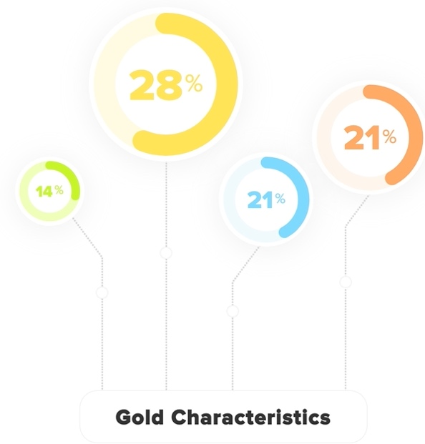

**Gold Characteristics**

Your true color is gold! Gold individuals usually are:

* Loyal
* Dependable
* Prepared
* Organized
* Caring

**Famous - Gold**

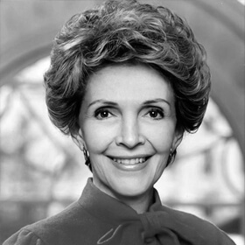Nancy Reagan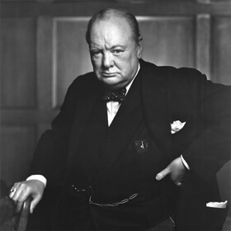Winston Churchill

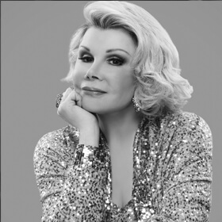Joan RiversHenry Ford

**Live up to your full potential - without doing the guesswork of how to get there**

* Find the [perfect career path](https://my-personality-test.com/true-colours/orange) for your personality type
* Realize there is a whole [community of people](https://my-personality-test.com/true-colours/green) just like you
* Develop your talents and transform your [weaknesses](https://my-personality-test.com/true-colours/blue) into opportunities...

**Here’s Why You’re Stuck in the Same Place (Personally and Professionally)**

Every day, you question how you got here.

Wandering through life lost and confused...hoping answers will suddenly appear and solve your problems.

You’ve been trying to figure out which job will bring out the best in you and fill you with joy...

Meet someone who loves you for who you are and makes you burst with laughter...

**Understand why other people seem so different from you.**

**You think to yourself:**

“How exactly can I reach my full potential?”

And whether you’re looking to make a career change or become a better person...

**Here’s the truth:**

The secret to becoming your happiest, most successful self is understanding why you think and act the way you do.

If you know in your mind’s eye you want to...

Find out how to master your strengths and communication skills

And

Explore how you can improve your relationships with others (and yourself).

Then Keep Reading...

Cause what follows could easily be the most mind-blowing thing you’ll look back on a few weeks from now when you've finally met yourself and unearthed how to bring the best version of YOU to life.

But First...

**Peek Into Your Future as Someone Who Understands Themselves to the Core**

* You know what makes you tick – and can prevent yourself from getting worked up.  
  The result? You’re happier.
* You’re evolving into the person you always wanted to be.
* Your relationships are flourishing. You understand why your family, friends, and co-workers behave the way they do. This has allowed you to reach a place of harmony with them
* You feel seen. Your thoughts about yourself are validated – and you know who you are.
* You’re not alone. There are people with the same personality type as you all over the world. You’re welcomed into a community of people who learn and love just like you

These outcomes are well within your reach (whether you’ve been searching a few hours or several years)...

... but they DO depend on following a simple, tried-and-true roadmap.

One that uses easy-to-follow explanations while avoiding confusing psych jargon.

One that’s been the secret insight thousands of people used to climb the ladder of personal growth.

**Here it is:** our amazingly accurate guide to help light your path towards becoming your greatest you...

**Your Premium Personality Profile**

Your Premium Personality Profile is a proven guide to understanding who you are on the inside by leveraging the latest research, tools, and strategies on the market.

It’s not only built for people hoping to discover their natural strengths...

But for people wanting to find the right career path, improve their communication skills, and grow into a better person.

Know what makes you tick as a person, and how to translate that into a better personal and professional life.

[Get Everything for $24.99](https://my-personality-test.com/checkout/gold)100% Money Back Guarantee100% Money Back Guarantee

**See Who You Really Are and What Makes You Unique**

Your Premium Personality Profile is a proven guide to understanding who you are on the inside by leveraging the latest research, tools, and strategies on the market.

It’s not only built for people hoping to discover their natural strengths...

But for people wanting to find the right career path, improve their communication skills, and grow into a better person.

In this powerful guide, you’ll ...

* [**Understand your core strengths and weaknesses**](https://my-personality-test.com/true-colours/blue) so you can utilize the latest research, tools, and strategies to your personal and professional advantage
* Figure out [**Who you are why you repeatedly stumble**](https://my-personality-test.com/true-colours/green) into the same self-defeating patterns.
* How your mind tends to perceive and use information.
* [**Your Ideal Career.**](https://my-personality-test.com/true-colours/orange) Discover the best career path based on your personality type – and how certain habits help and hurt your chances at a job.
* [**How your personality type influences your communication style**](https://my-personality-test.com/true-colours/green) and how you can strengthen your communication with others.
* Why [**the secret to happy relationships and strong careers**](https://my-personality-test.com/true-colours/gold) is understanding why you think and act the way you do.
* How your personality type handles stress.
* [**Why you behave the way you do**](https://my-personality-test.com/overview/true-colours) in different situations...
* [**Your unique qualities as a romantic partner,**](https://my-personality-test.com/true-colours/green) parent, and friend. Find out which personality types get on your nerves – and the ones who could be your soulmate.
* [**How to build effective teams.**](https://my-personality-test.com/true-colours/orange) Understanding the personality types present on your team can make the difference between a smoothly functioning cooperation and a misstepping group of adversaries frustrating each other. How your personality type handles stress.
* How others really perceive you.
* The strength and weaknesses of your decision making processes.
* The limitations of personality profiles and the important factors they don’t measure.
* How your worldview is [**driven by your personality.**](https://my-personality-test.com/true-colours/gold)
* [**Your level of emotional intelligence.**](https://my-personality-test.com/true-colours/blue)
* Which factors tend to [**drive your decision making**](https://my-personality-test.com/overview/true-colours) and how those help and hurt your decision making.
* Better understand personal relationships and how your [**perceptions differ from others.**](https://my-personality-test.com/true-colours/gold)

**How this profile is structured**

The premium profile is divided into five basic easy to understand sections

1Section 1 lays out your unique characteristics. What brings you joy? What do you value most? What are your greatest needs? What causes you stress?**+ MORE!**

2Section 2 teaches you the unique ways you learn and what jobs you are best suited for.

3Section 3 concludes by showing you how you perceive and interact with other personality types. Which types you connect with and which types tend to clash.

**Here’s What Premium Personality Profile Customers Have to Say...**

‘‘Damon D. reached a new level of personal growth

“The Premium Personality Profile offers a really substantial step on the ladder of personal growth.”

‘‘Ron L. reached a new level of personal growth

“Premium Personality Profile gave me an in-depth look at my own personal traits, with a deeper understanding of how I interact with other people, and what makes me tick. I highly recommend this to individuals who are on self exploration trying to better understand and know themselves. ‘Know thyself’ is indeed a goal, & Premium Personality Profile is one excellent way to begin the journey!”

‘‘Jill B. knows her strengths and weaknesses

“It is a great way to prepare for an interview and understand where you can develop and strengthen areas where you are weaker. Mine was amazingly accurate and a big help.”

‘‘Hannah M. communicates more effectively with others

“I gained a wealth of knowledge of my personality type through the Premium Personality Profile, despite having completed the assessment. The descriptions provide accurate assessments of how I think and act in various situations and help me to better understand how to tailor my communication style to various other personality types.”

**Questions Your Fellow GOLD’s Asked Before Saying ‘YES’ to the Premium Personality Profile**

[I’m worried the profile is filled with confusing psych language.  
How reader-friendly is it?](https://my-personality-test.com/results/6874431008031939740/true-colours" \l "accordion-1)

The Premium Personality Profile uses easy-to-understand language to describe how to achieve your goals, advance your career, and build stronger relationships. Don’t worry: there’s no need to look up psychology jargon in a dictionary.

[I don’t know if I NEED a Personality Profile right now.  
How will this actually help me?](https://my-personality-test.com/results/6874431008031939740/true-colours" \l "accordion-2)

[What makes Premium Personality Profile different from other personality-related information out there](https://my-personality-test.com/results/6874431008031939740/true-colours" \l "accordion-3)

[I’ve never purchased anything relating to my personality type before.  
Are you sure I can learn from this?](https://my-personality-test.com/results/6874431008031939740/true-colours" \l "accordion-4)

**Still Undecided?**

You’re ready to tap into profound thinking about your personality type if...

1**You want more insight on a career change** and which jobs are a good fit for you based on who you are and how you think.

2**You’re interested in improving yourself** but aren’t sure where to begin. You know it would be much easier with a helpful guide.

3**You’d like to understand yourself better** and why you feel and act in certain ways.

4**You want to see how others think differently than you** to improve communication with the people in your life.

5

**You’re excited to learn more about personality types** and would love to get your hands on even more information.

If you caught yourself nodding your head to at least 2 of the 5 points above, you owe it to yourself to experience your Premium Personality Profile.

“I found this profile to be easy to follow and understand. I came away knowing myself a good deal better."

– Jill B.Premium Personality Profile Customer

**Transform Into The Best You In Just a Few Days**

By now, you already know that the biggest difference between staying trapped in **“What Do I Do With My Life?”** limbo and becoming more confident, happy, and fulfilled all comes down to...

Your Premium Personality Profile.

So if you’re still here...let’s be completely honest.

If you’re going back and forth on what’s the right job for you...you need the Premium Personality Profile.

If you want to improve communication with your family, friends, and coworkers (who seem so different from you)...you need the Premium Personality Profile.

If you’d like to know the type of personality to go for when searching for your soulmate... . You need the Premium Personality Profile.

If you just want to SEE yourself for who you really are and then use those insights to become a better you... You need the Premium Personality Profile.

and...

If you’ve got your sights set on a life filled with pure joy, success, and flourishing relationships, you need the Premium Personality Profile.

Don’t you agree it’s time to live a rewarding life? If so, click the button below to get your Premium Personality Profile right now.